SONG JOURNEY
"Sweet Child O' Mine"
Guns N' Roses
Thread song — it grows through Modules 1–5, with a Module 7 finale
One song, five layers. Each module adds a new tool to this song. Layer 6 is a bonus — the famous intro riff.
Form Intro riff → Verse → Chorus → Verse → Chorus → Guitar solo → Outro
Verse chords D · C · G
Chorus chords A · C · D
Rhythm Verse: 2 bars per chord. Chorus: about 1 bar per chord — twice as fast.
Tempo Practice at 60 BPM. The record is tuned a half-step lower — your version sounding slightly higher is normal.
LAYER 1 Listen Module 1
The intro is played one note at a time — no chords, no strumming — and it's still instantly recognizable. Listen for how the single-note riff sketches the chords underneath the band.
Play it: Listen to the first minute.
Count how many times the intro riff repeats before the vocals start.
Notice the moment the drums arrive.
You've got it when: You can hum the main hook from memory.
Level up
Listen once more. Find where the guitar solo starts.
What changes? ______________________________
LAYER 2 Bass Roots Module 2
Three notes on the two lowest strings carry the whole verse — the root of each chord, one every two bars. This is the song stripped down to its simplest notes, and it still works.
Verse bass roots · low E & A strings · one note per 2 bars
D D C C G G D D (loop)
e |--------|--------|--------|--------|--------|--------|--------|--------|
B |--------|--------|--------|--------|--------|--------|--------|--------|
G |--------|--------|--------|--------|--------|--------|--------|--------|
D |--------|--------|--------|--------|--------|--------|--------|--------|
A |--5-----|--5-----|--3-----|--3-----|--------|--------|--5-----|--5-----|
E |--------|--------|--------|--------|--3-----|--3-----|--------|--------|

Play it: One note every 2 bars at 60 BPM.
Strike it on beat 1 of each bar.
Say the note names out loud: D, C, G.
You've got it when: You can play it from memory at 60 BPM, no stops.
Level up
Play each root once per beat — 8 times across the two bars — instead of letting it ring.
Now you're the bass player.
Level up · one root note per beat · verse loop
D D C C
e |----------------|----------------|----------------|----------------|
B |----------------|----------------|----------------|----------------|
G |----------------|----------------|----------------|----------------|
D |----------------|----------------|----------------|----------------|
A |--5--5--5--5----|--5--5--5--5----|--3--3--3--3----|--3--3--3--3----|
E |----------------|----------------|----------------|----------------|

G G D D (loop)
e |----------------|----------------|----------------|----------------|
B |----------------|----------------|----------------|----------------|
G |----------------|----------------|----------------|----------------|
D |----------------|----------------|----------------|----------------|
A |----------------|----------------|--5--5--5--5----|--5--5--5--5----|
E |--3--3--3--3----|--3--3--3--3----|----------------|----------------|

LAYER 3 Power Chords Module 3
Same three roots from Layer 2 — each note now also plays the note a fifth above it. This layer covers the whole song: the verse loop, the chorus that answers it twice as fast, and the outro run at the end of the record.
Verse power chords · 2 bars per chord · 60 BPM
D5 D5 C5 C5
e |--------|--------|--------|--------|
B |--------|--------|--------|--------|
G |--------|--------|--------|--------|
D |--7-----|--7-----|--5-----|--5-----|
A |--5-----|--5-----|--3-----|--3-----|
E |--------|--------|--------|--------|

G5 G5 D5 D5 (loop)
e |--------|--------|--------|--------|
B |--------|--------|--------|--------|
G |--------|--------|--------|--------|
D |--------|--------|--7-----|--7-----|
A |--5-----|--5-----|--5-----|--5-----|
E |--3-----|--3-----|--------|--------|

Play it: Eight beats per chord — two bars each — at 60 BPM.
Four clean laps, both strings ringing.
Watch the G5 — the root drops to the low E string.
Chorus power chords · 1 bar per chord · 60 BPM
A5 C5 D5 (loop)
e |--------|--------|--------|
B |--------|--------|--------|
G |--------|--------|--------|
D |--2-----|--5-----|--7-----|
A |--0-----|--3-----|--5-----|
E |--------|--------|--------|

Play it: One bar per chord — half the verse length — at 60 BPM.
Slide the same two-finger shape up the neck: A5 to C5 to D5.
Land the shift right on beat 1 of each new bar.
Outro power-chord slide · about 1 bar per chord · 60 BPM
E5 G5 A5 C5 D5 (loop)
e |--------|--------|--------|--------|--------|
B |--------|--------|--------|--------|--------|
G |--------|--------|--------|--------|--------|
D |--------|--------|--------|--------|--------|
A |--2-----|--5-----|--7-----|-10-----|-12-----|
E |--0-----|--3-----|--5-----|--8-----|-10-----|

Play it: About one bar per chord at 60 BPM.
Slide one shape down the low E string through all five chords.
This is the record's own ending — "where do we go now" and all.
You've got it when: The loop runs at 60 BPM, every string ringing clean, no stops.
Level up
Palm-mute (PM) the verse power chords for the recording's chug — a short, muted, punchy strum.
Then let the same shapes ring open for one loud lap.
LAYER 4 Pentatonic Solo Module 4
The famous outro solo lives in E minor pentatonic. You know the open-position box — the block of frets where the pattern sits — and the same shape one octave up at fret 12 is the instant "solo voice."
Four rungs. Climb them in order.
Rung 1 · Rule of 3 — start here
Open position · full box (E · G · A · B · D)
e |--0----------3--------------------|
B |--0----------3--------------------|
G |--0-------2-----------------------|
D |--0-------2-----------------------|
A |--0-------2-----------------------|
E |--0----------3--------------------|

Fret 12 box · same shape, one octave up — the "solo voice"
e |--12---------15--------------------|
B |--12---------15--------------------|
G |--12------14-----------------------|
D |--12------14-----------------------|
A |--12------14-----------------------|
E |--12---------15--------------------|

Play it: Improvise 4 bars in the open position.
Then 4 more at fret 12 — same pattern, one octave up.
Phrases with space, landing on E in each register.
Rung 2 · The two-octave climb
1. Climb the open box from the low E string to the high e string.
2. Make the exact same climb at fret 12.
3. Connect them: climb the open box, jump to fret 12, and keep climbing without stopping — one run, two octaves.
The climb · E minor pentatonic, open position (then repeat at fret 12)
e |------------------------------------------0---3-|
B |----------------------------------0---3---------|
G |--------------------------0---2-----------------|
D |------------------0---2-------------------------|
A |----------0---2---------------------------------|
E |--0---3-----------------------------------------|

Rung 3 · Hammer-ons and slides
1. Hammer-on (h): pick the first note, then tap the higher fret hard with your ring finger — two notes, one pick.
2. Slide (/): pick once, keep pressing, glide up.
Dress-ups · h = hammer-on · / = slide · fret-12 box
D E G A D E E
e |--------------------|--------------------|
B |--------------------|--------------------|
G |------------12h14---|--------------------|
D |--12h14-------------|--12/14-----14------|
A |--------------------|--------------------|
E |--------------------|--------------------|

Play it: Practice each move slowly until the second note sounds clearly.
Add them to your Rung 1 phrases.
Rung 4 · Two outro-solo licks
Two licks (short solo phrases) from the same box to start your solos.
Lick 1 · down and back up · lands on E
G E D E
e |--15---12--------12-|
B |------------15------|
G |--------------------|
D |--------------------|
A |--------------------|
E |--------------------|

Lick 2 · ascending · lands on E
A B D E
e |--------------------|
B |--------------------|
G |--------------------|
D |------------12---14-|
A |--12---14-----------|
E |--------------------|

Play it: Learn each lick exactly.
Then change one note, or change the rhythm.
You've got it when: You've climbed all four rungs — dress-ups and licks in your solos.
Level up
Slide between the two positions mid-phrase.
Or hold your longest note an extra bar and let it sing.
Level up · slide between positions · 2 bars
E (slide) G A
e |--------------------|--------------------|
B |--------------------|--------------------|
G |--------------------|------------14-------|
D |--------------------|--12---------------|
A |--------------------|--------------------|
E |--0/12---------------|--------------------|

LAYER 5 Open Chords Module 5
The simple singalong version. The verse loop becomes three full open chords you can strum and sing over — the whole song from just D, C, and G.
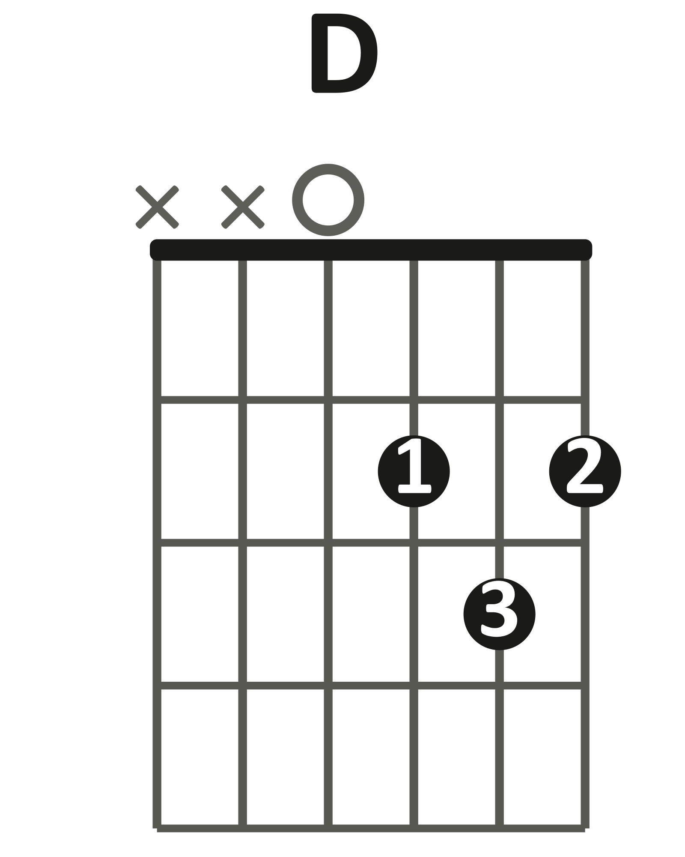 | 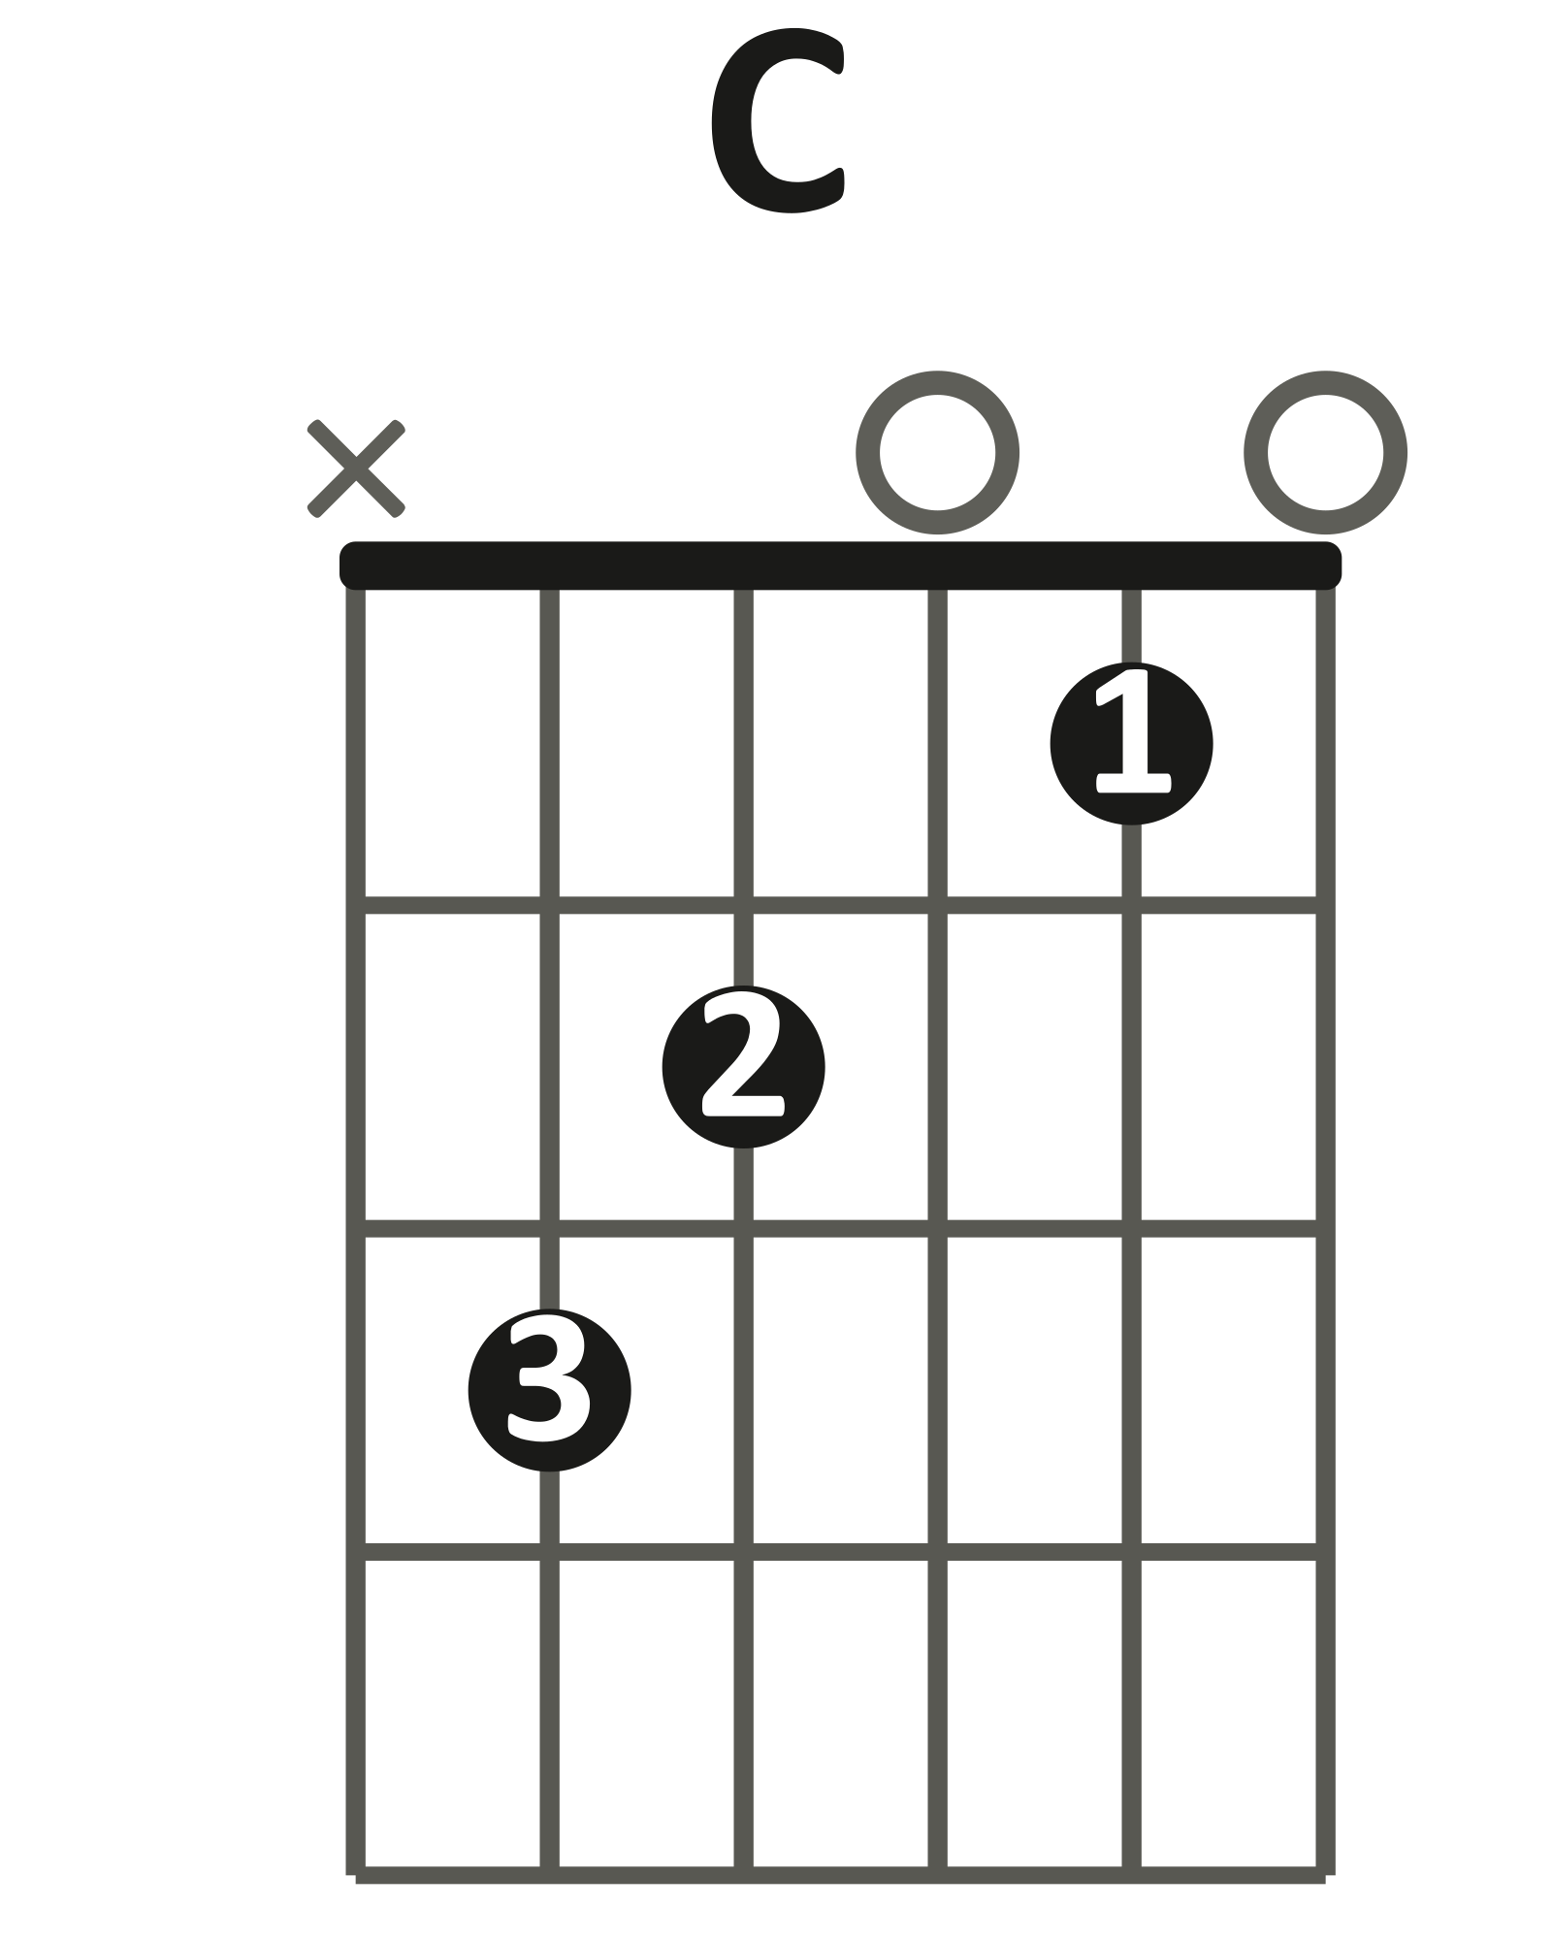 | 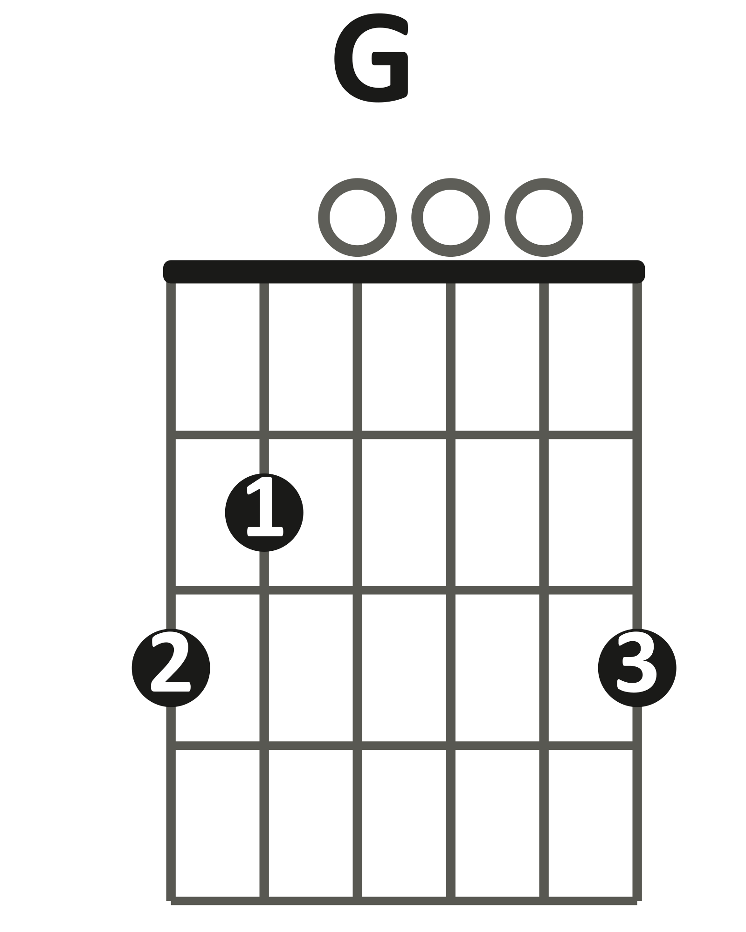

Verse loop · 2 bars per chord · 60 BPM
| D | D | C | C |
1 2 3 4 1 2 3 4 1 2 3 4 1 2 3 4

| G | G | D | D | (loop)
1 2 3 4 1 2 3 4 1 2 3 4 1 2 3 4

Play it: Down-strums, two bars per chord — four strums, then four more, before the change.
One full verse loop with every change landing on beat 1.
Try humming the intro riff while you strum.
You've got it when: The full loop runs at 60 BPM with every change on the beat.
Level up
Folk strum on every chord: D D U U D U.
Level up · folk strum · one bar per chord
| D | C |
1 2 & 3 & 4 & 1 2 & 3 & 4 &
D D U U D U D D U U D U

| G | D |
1 2 & 3 & 4 & 1 2 & 3 & 4 &
D D U U D U D D U U D U

LAYER 6 The Intro Riff Bonus
Bonus layer — optional harder challenge, no score. Best once Layer 4's fret-12 box feels automatic.
This is one of the most famous guitar openings ever recorded — and it sits almost exactly where Layer 4 already put your hand. Slash holds still and lets the picking hand skip between strings; the fretting fingers barely move.
Played slow, it's a melody. Played fast, it's the intro.
Intro riff · one note per beat · loops over the D bar · 60 BPM
D D A G G A F# A
e |--------------------|--15--------14------|
B |-------15-----------|--------------------|
G |------------14---12-|-------14--------14-|
D |--12----------------|--------------------|
A |--------------------|--------------------|
E |--------------------|--------------------|

Play it: One note per beat at 60 BPM — the famous opening, slowed down.
Bar 1 climbs: D, high D, A, G.
Bar 2 answers on the high strings: high G, A, F#, A.
You've got it when: You can loop the riff cleanly at 60 BPM, no buzzing.
Level up
Loop the riff twice, then land on a big D5 power chord.
Or play it while a partner strums the Layer 5 verse loop.
Level up · D5 ending · 1 bar
D5 (big finish)
e |--------|
B |--------|
G |--------|
D |--7-----|
A |--5-----|
E |--------|

FULL CHORD CHART
"Sweet Child O' Mine"
Guns N' Roses
Key D major shapes (the record is tuned a half step lower — sounding slightly higher is normal)
Tempo 125 BPM · 4/4
Rhythm Verse: two bars per chord. Chorus and outro: about one bar per chord.
Form Intro riff → Verse → Chorus → Verse → Chorus → Guitar solo → Outro
Shapes you need
D | C | G | 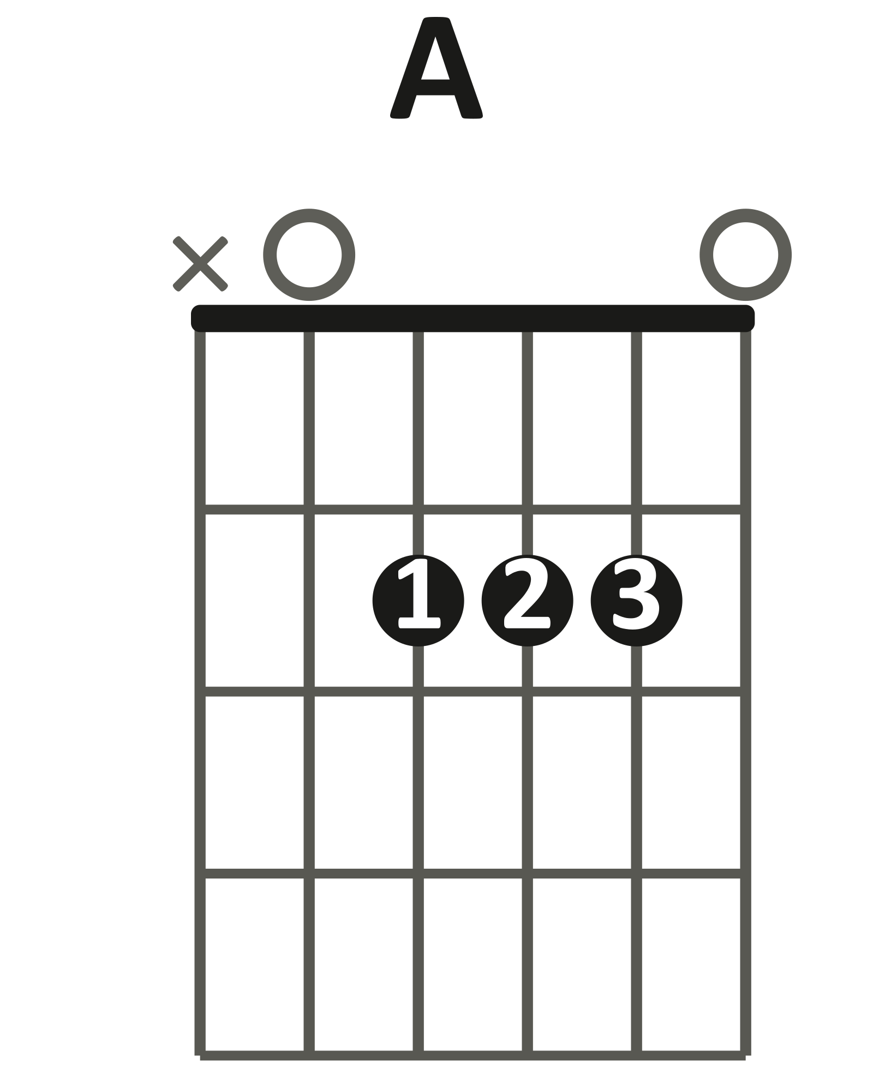  A | 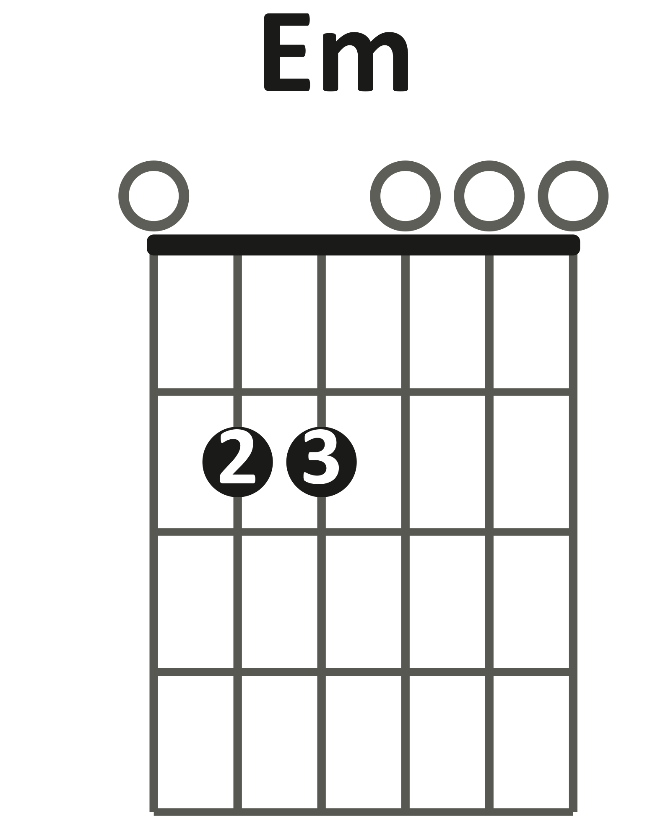  Em

INTRO RIFF
| D | D |
The famous riff loops over the D bar (Bonus layer). Strummers hold D.
VERSE
| D | D | C | C | G | G | D | D |
Repeat the eight bars until the chorus. The record plays Cadd9 for the C — the plain C shape works.
CHORUS
| A | C | D | A | C | D |
Twice through A · C · D. Moves twice as fast as the verse.
VERSE
| D | D | C | C | G | G | D | D |
Same as the first verse.
CHORUS
| A | C | D | A | C | D |
Same as the first chorus.
GUITAR SOLO
Lead section — not played by the class. The verse and chorus chords run underneath it.
OUTRO
| Em | G | A | C | D |
"Where do we go now" — repeat the five bars to the end. About one bar each.
Teaching chart — simplified to match the Journey layers, not a note-for-note transcription. Chord names are what the class plays in standard tuning.

